**Learning Outcomes**

1. Understanding SQLite Databases on Android
2. Add, Edit, Delete functionality.

**Adding To Do Items**

**Add Items**

**Create a new Layout**

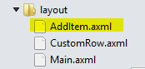

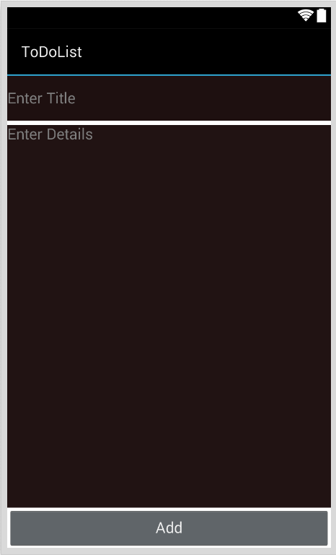

**Add functionality**

**DatabaseManager.cs**

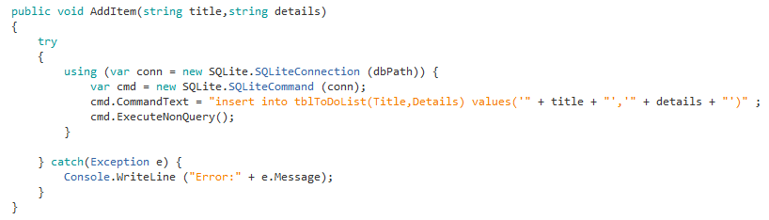

**Add a new activity name it AddItem.cs**

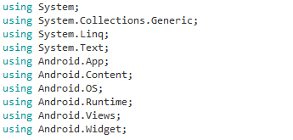

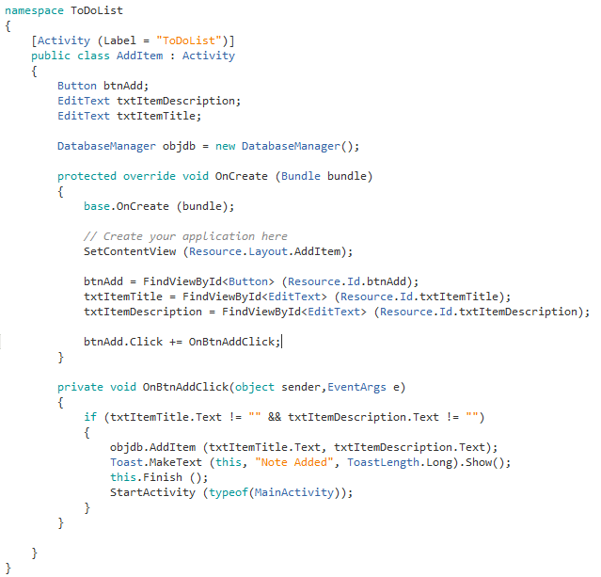

**MainActivity.cs**

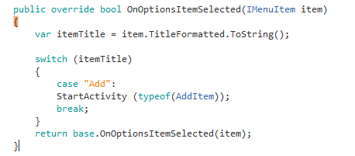

**Edit and Delete Functionality**

**Design the EditItems.axml**

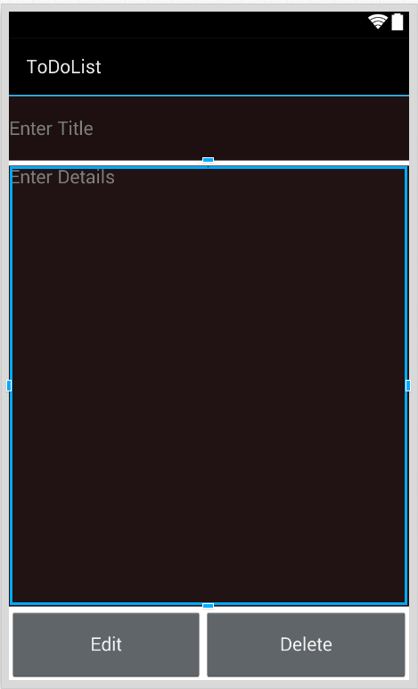

**DatabaseManager.cs**

**Edit and Delete Items**

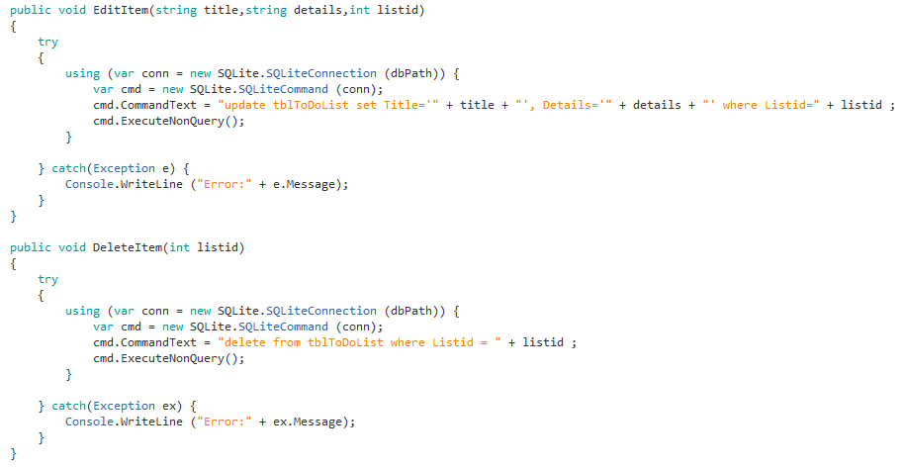

**EditItem.cs**

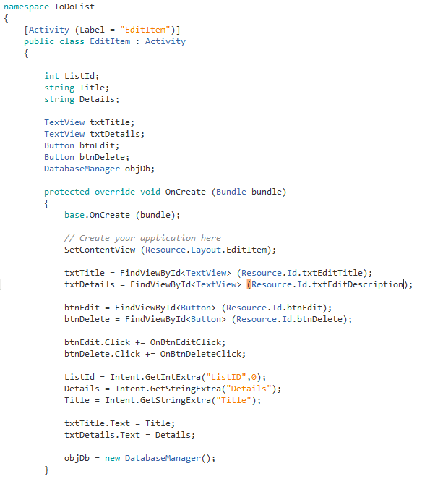

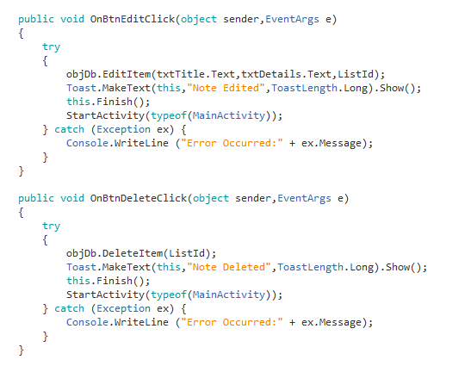

**MainActivity.cs**

Add the click event for the list view

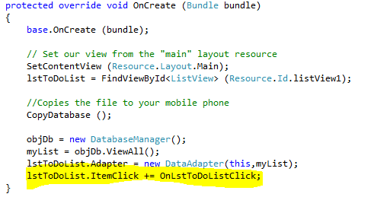

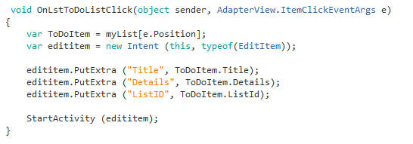

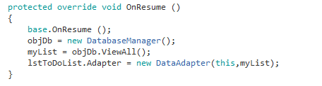

**Exercise**

1. Try to Implement the Search functionality
2. Customize your buttons and add bitmaps to it to make it look good.